Contact Management System (CMS)

The Contact Management System (CMS) allows you to store your different types of acquaintances: relatives, personal friends, professional friends, and casual acquaintances. For different types of acquaintances, different types of information will be stored.

An initial implementation (source code) of the CMS prior to the application of design patterns is given to you. The CMS allows you to add, delete, edit, search, view full details of different types of acquaintances. It also allows you to save the acquaintances details into a file and to read the acquaintances details from a file. The main user interface of the CMS is given below. To run CMS as a Java application, right click on *ContactManagementSoftware.java* and click run file. To run CMS as an applet, right click on *CLJApplet.java* and click run file.

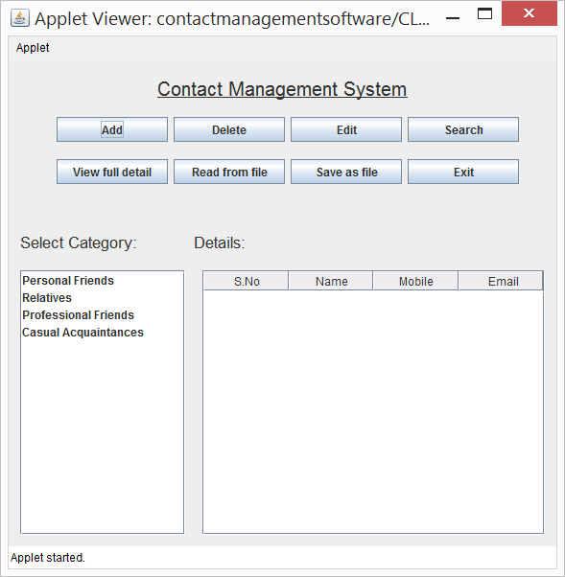

Acknowledgment: The initial implementation of the CMS is from <https://github.com/ritz301/Contact-Management-System>